Article

Sliding Mode Set-Point Control of a three-DOF Cable-Suspended Parallel Robot with Uncertain mass and Disturbances

Ping Ren 1,*, Xu Sheng 2

1 Department of Automation Science and Engineering, College of Engineering, Ocean University of China, Qingdao 266100, China

2 Department of Automation Science and Engineering, College of Engineering, Ocean University of China, Qingdao 266100, China;21170911103@stu.ouc.edu.cn

**\*** Correspondence: robotics@ouc.edu.cn

Received: date; Accepted: date; Published: date

**Abstract:** Cable-Suspended Parallel Robots (CSPRs) utilize winches and cables as the actuation scheme instead of rigid links, which renders them advantages of both parallel mechanisms and cable mechanisms. In this paper, a robust sliding mode controller was designed for a three-degree-of-freedom CSPR with uncertain end-effector mass and external disturbances. The control of CSPRs is usually a challenging task due to the unidirectional constraints of cable tensions. Based on interval arithmetic, a set of analytical inequalities are obtained which establishes the relationship between the cables’ tension constraints and the controller parameters. The sufficient conditions of the controller parameters satisfying the constraints are obtained for the set-point motion subject to uncertainties. Numerical simulations are presented to verify the effectiveness of the proposed approach.

**Keywords:** cable-suspended parallel robot; sliding mode control; interval analysis; tension constraint

1. Introduction

Cable-driven parallel robots (CDPRs) are a special class of parallel robots in which rigid links between the static base and the mobile platform are replaced with winches and cables. The research and development of CDPRs originated in late 1980s. One of the first CDPR prototypes, known as Robocrane, was developed by NIST in 1993 [1]. Compared with conventional parallel robots, a typical CDPR usually has the advantages of larger workspace, lower inertia and higher speed. Additionally, the simple structure of winch and cable makes the robots easily modularizable, thus greatly reducing the cost of manufacture and maintenance. Thanks to the merits above, CDPRs have been applied in many fields nowadays, such as material handling, astronomical observation, and motion simulation, etc [2].

CDPRs can be generally classified into two groups: cable-suspended parallel robots (CSPRs) and fully-constrained cable-driven parallel robots [2]. Traditionally, if the number of the cables is identical to the number of DOF of the mobile platform, such type of CDPRs can be referred as CSPRs. However in recent years, many underactuated and redundantly actuated CSPRs have emerged, so the same number of cables as the DOF seems not an appropriate and exclusive standard. A refined description of a CSPR could be, the mobile platform is suspended against gravity with cables above it. In other words, gravity is the only factor that ensures all cables’ tensions and no preloaded lower cables exist. At present, intensive research has been conducted on the kinematics analysis, dynamics modeling and control of CSPRs [2, 3].

However, the characteristic that cables can only apply tensile forces makes the control of CDPRs an even more challenging task. Regarding the ways how tension constraints were treated for CDPRs, there were generally three types of approaches suggested in previous literatures:

1. Empirical methods

The controller parameters were tweaked repeatedly based on simulation or experimental results until the tension constraints were met. This method relied heavily on experience of parameter adjustment. For example, a sliding mode controller for a three-DOF CSPR was designed in [4] and the control gains were obtained through experiments. In [5] a fuzzy PI controller for a six-DOF CSPR was developed and the controller parameters were obtained from simulations and experiments.

1. Optimization of tension distribution

For the fully-constrained CDPRs, the control force of the end-effector can be distributed to each cable with an optimization algorithm in consideration of the tension constraints of the cables. For instance in [6], the linear and the quadratic programming methods were adopted to distribute the tensions of a feedback linearization controller for the four-, five-, and six-cable configurations of a planar three-DOF CDPR. In [7], a robust PID controller was proposed for a planar four-cable three-DOF CDPR and the tensions were distributed with the null space method. In [8], existing tension distribution optimization algorithms were reviewed and a non-iterative distribution algorithm was proposed and then applied to the visual servo controller of an eight-cable six-DOF CSPR.

1. Workspace analysis

For CSPRs without redundant cables, the tension distribution could not be optimized, and the tension constraints could be handled in association with workspace analysis. The reachable workspace was derived for the current controller parameters, and the end effector reached the desired position step by step by setting multiple steady via points between the initial and the target point. As an example in [9], the via points in the reachable workspace of a feedback linearization controller were obtained through the planning of the reference inputs based on the idea of model prediction. In their subsequent works [10,11], the reachable workspace that satisfied the tension constraints was described with analytical inequalities, which made the calculation of via points more efficient.

In addition to the above-mentioned three types of approaches, this paper proposes a different method to deal with the tension constraints in the control studies on cable-suspended parallel robots. In this method, the analysis on the reachable workspace is converted to the analysis on the controller parameter space. With given initial point and target point, the reliable controller parameter space that satisfies tension constraints is obtained, which ensures that the end effector reaches the target point in just one step without going through a series of via points.

The three-cable three-DOF CSPR to be studied in this paper was firstly proposed by Gorman et al. in 2001 as a new type of robotic crane [4]. It has received much attention in recent years. In [12-15], the planning of dynamic point-to-point trajectories and periodic trajectories was studied. In [16], the positioning accuracy of this CSPR was evaluated by using a VICON motion capture system. In [17], a nonlinear cable tension model was implemented to the three-DOF CSPR in order to quantify the vibration characteristics of cables.

In this paper, a robust sliding mode controller is designed for the set-point motion of the three-DOF CSPR. First the dynamic equations required for control procedure are represented. Then the interval arithmetic is used to obtain sufficient conditions of the reliable controller parameters space that always generates positive cable tensions. Finally the effectiveness of the designed controller is proved by performing simulations. The proposed method can guarantee that the end-effector of the three-DOF CSPRs converges exponentially to the target point within its static workspace. In our previous work in [18], this method has been applied to the design of a sliding mode controller for a six-DOF CSPR with uncertain external disturbances but accurate mass. However in this paper, both uncertain mass and uncertain disturbances are considered.

2. Dynamic Model

The configuration of the three-DOF CSPR is shown in Fig. 1. Three winches are fixed to the horizontal frame, and three cables are connected to the end-effector for suspension. The end-effector is considered as a point mass and its static workspace can be considered as the volume within the three lines passing downward through the fixed points of the winches in the direction of gravity.

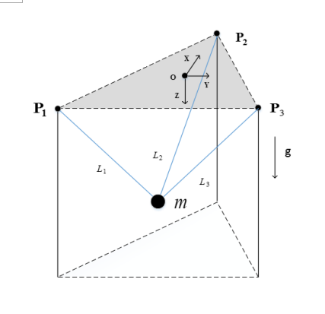

Fig.1 The schematic of a three-DOF CSPR

A Cartesian coordinate system is established on the fixed base, and the edge length of the base is denoted as 2a.Ignoring the mass and elasticity of the cables, the dynamic equations can therefore be written in the following form using Newton’s laws.

 (1)

where denotes the position vector of the end-effector with mass m. M = diag([m,m,m]) is the mass matrix for the system; is the force Jacobian matrix;  is the vector of gravity acceleration; is the vector of the cable tensions, and  is the external disturbance vector.

3. Sliding Mode Controller

The objective of this control study is to realize the set point motion of the three-DOF CSPR within its static workspace while satisfying the tension constraints of the cables and resisting uncertainties. A sliding mode controller is thus developed to achieve it.

The procedures to design the controller follow the descriptions in [19]. A sliding surface and a Lyapunov function are defined firstly:

 (2)

 (3)

where  . The desired position vector is set as:

 (4)

Differentiate the Lyapunov function in Eq. (3).

 (5)

Taking into account the uncertainties of mass m and external disturbances d(t), assume that , .

The control law is then selected as:

 (6)

where , .

Note that is the nominal value of uncertain mass m; with are the nominal values of external disturbances; sgn(s) = [sgn(s1), sgn(s2), sgn(s3)]T .

Eq. (5) and (6) lead to

 (7)

where ,, assume, so .

And Eq. (7) leads to



In order to make the Lyapunov function’s time derivative, *ki* is selected as:

 (8)

Apparently, parameters andboth play critical roles in the sliding mode control laws. If the initial state is not on the sliding surface, ensures that the Lyapunov function decreases over time and the surface will be reached in finite time. Once on the surface,makes sure the convergence of the states to the desired. The selection of  and  must be satisfied the tension constraints of the cables. So the sufficient conditions with respect toandthat guarantee positive tensions are derived analytically in the following sections.

4. Determination of Controller Parameters

4.1. Intervals on States

In order to determine the feasible space of the control parameters and that satisfy the tension constraints, the intervals on states andof the CSPR governed by the sliding mode controller should be obtained first. To achieve this, interval arithmetic or interval analysis is then utilized, which is an efficient tool operated on the bounds of variables. Detailed tutorial on interval arithmetic can be found in [20].

The controlled set point motion of the CSPR can be divided into two phases. In the first phase, the system states reach the sliding surface from an initial condition within finite time. In the second phase, all the states slide along the surface to reach.

Regarding the first phase, we assume the following initial conditions:

 and  (9)

So the system states start in the region with. Then  until the system states reach the sliding surface. The bounds of  are obtained from Eq. (10) and then used to determine the intervals of states.

 (10)



where,.

Since in the first phase, solving  gives:



Since, we can obtain. By means of interval arithmetic, we can obtain:

 ,,  for Eq. (10).

Therefore the intervals of are determined as:

 (11)

Similarly, the intervals of  when  are:

 (12)

The interval inequalities obtained from Eq. (11) are as follows:

 (13)

Rearrange Eq. (13), we now have:

 (14)

where , , ,, i =1,2,3.

For convenience, the state along x axis is illustrated in the following section. Other states just follow the same procedures. Start with Eq. (14) and i = 1, we can have:

 （15.1）

 （15.2）

Define  and  as the corresponding time and the value of  when arriving at the sliding surface. It can be inferred that in the first phase,  and.

The interval of is obtained by first solving differential inequalities using Laplace transformation and convolution.

For Eq. (15.1), assume that 

 (16)

Similarly, for Eq. (15.2), the interval of in the first phase can be obtained:

 (17)

Combining Eq. (16) and (17), the following interval is obtained for x:

 (18)

The interval of is obtained by using Newton-Leibniz differentiation for Eq. (16). The derivation is as follows:

 (19)

Similarly for Eq. (15.2), one can obtain, so the following interval is obtained for:

 (20)

With Eq. (15.1),(15.2) and (20), the interval of  can be shown as:

 (21)

Since , use as the example.

Using Eq. (20) and (21), we can have:



Since, the interval of  can be slightly extended for a simpler form:

 (22)

Assume that , where, .

 (23)

Combining Eq. (18) and (23), the interval of  is shown to be:

 (24)

Since, the interval of  can be slightly extended for a simpler form as well:

 (25)

Similarly, based on Eq. (20), (21) and (23), we can obtain the extended intervals of and as follows:



 (26)

As for the second phase, we only need to look into the behaviours of the states on the sliding surface. With an initial time  and an initial value, solving  gives:

 (27)

Therefore, we can obtain,, .

With Eq. (24), the intervals of,, are shown as:

 (28)

Combine solutions from the first and the second phase, the overall intervals are determined as:

 (29)

Hence, the intervals of the controlled states are obtained successfully, which will be used to in the next subsection to determine the intervals of the parameters andwhile satisfying the tension constraints.

4.2. Tension Constraints as Inequalities

Based on the dynamic model in Eq. (1), since the cables can only exert positive tensions, the three tension constraints of the system can be described as the inequalities below:

 (30)

Take the first inequality  as an example. In order to perform interval operations, the upper and the lower bounds of each state interval are defined as:



Additionally, the upper and lower bounds of the uncertain mass m and the uncertain external disturbance  are as follows:

,

Since the set-point motion of the end-effector only takes place within the static workspace described by:

,

The signs of some interval bounds can be determined as:

.

Therefore, the interval operations of the first inequality in Eq. (30) are performed as:

 (31)

Following the same procedures, all three inequalities corresponding to those in Eq. (30) are obtained as below:

 (32)

Substitute the intervals obtained in Section 4.1 into the inequalities in Eq. (32) for the first phase with . One can obtain:

 (33)

Repeat the same operations based on the intervals obtained for the second phase with . One can obtain:

 (34)

With these inequalities above, the sufficient conditions on control parameters andare now established analytically, which guarantees the tension constraints of the three-DOF CSPR are always satisfied during the set-point motion within its static workspace in the presence of uncertain mass and disturbances.

1. Numerical Example

In this section, numerical simulations are presented to verify the sliding mode controller proposed, and the feasibility of the controller parameters. For the three-DOF CSPR in Fig.1 and its dynamic model in Eq. (1), the simulation parameters are listed in Table 1. The uncertain end-effector mass varies within a given range. The uncertain external disturbances are included in the model with. The initial and the desired positions of the set-point motion are pre-specified.

Firstly, as shown in Fig. 2(a), the sufficient conditions of the control parameters and  represented by the six inequalities in Eq. (33) and (34) have divided the two-dimensional parameter space into different regions. And the shadow region which represents the feasible control parameters that satisfy the constraints of the cable tensions, is obtained as an overlap of all these regions. The portion inside the red box in Fig. 2(a) is enlarged and presented in Fig. 2(b) for a clearer view.

**Table 1.** Simulation parameters for the 3-dof CSPR

|  |  |  |
| --- | --- | --- |
| Description | Values | Units |
| Edge Length of the Base (2a) | 2 | m |
| Mass (m) | 0.8~1.2 | kg |
| Gravity Acceleration (g) | 9.8 | m/s2 |
| Initial Position () |  | m |
| Desired Position () |  | m |
| Bound of the Disturbance Force in x () | 0.05 | N |
| Bound of the Disturbance Force in y () | 0.05 | N |
| Bound of the Disturbance Force in z () | 0.05 | N |

line-combine10line-combine10line-combine10line-combine10line-combine10line-combine10line-combine10line-combine10

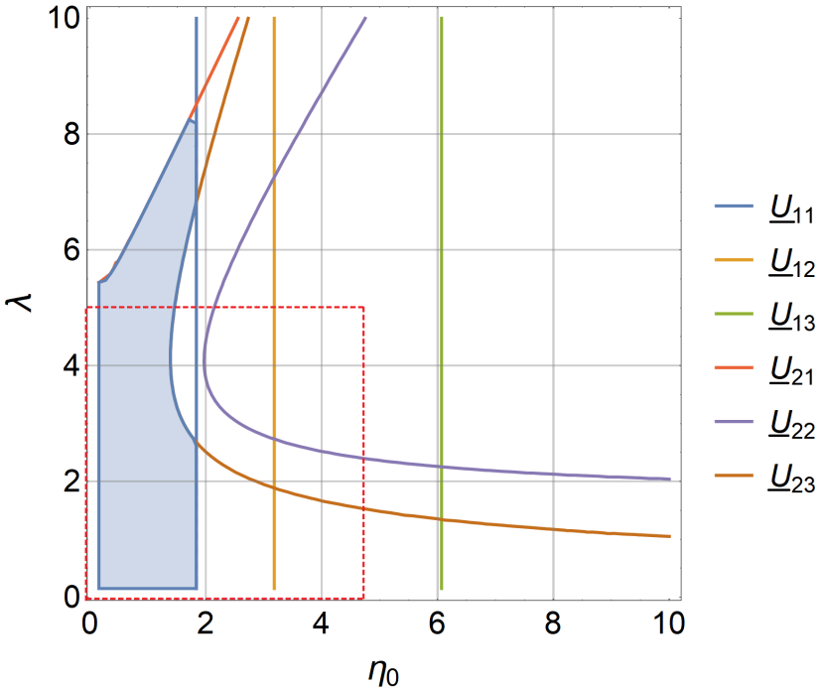line-combineline-combineline-combineline-combineline-combineline-combine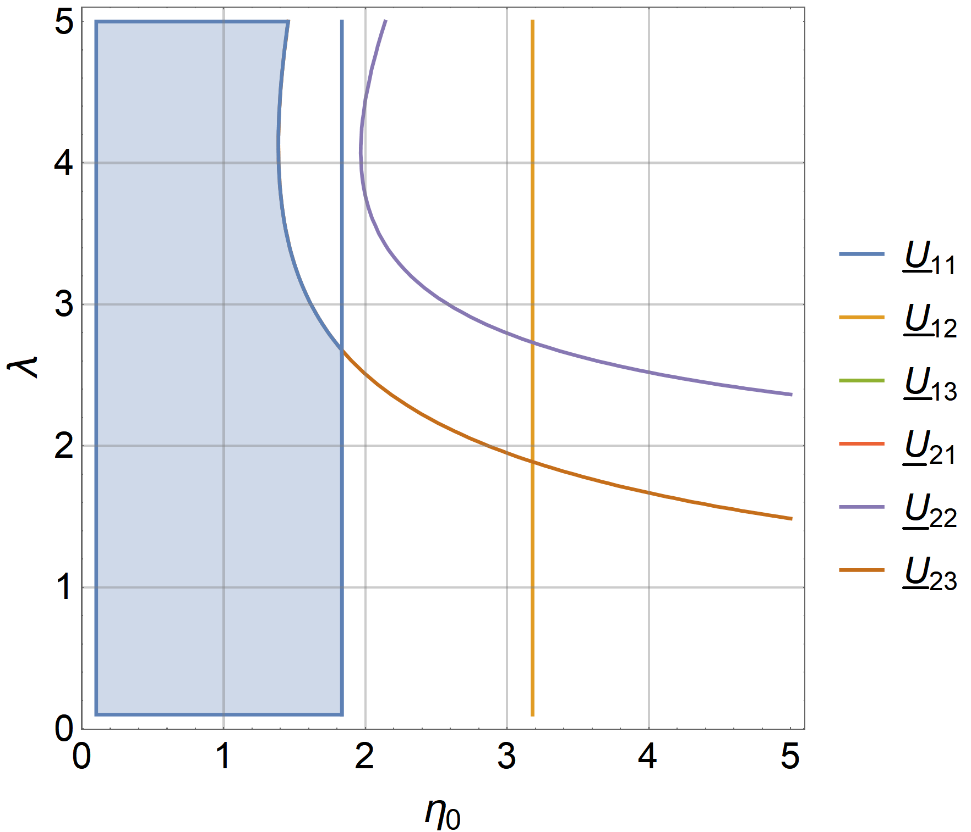

(a) (b)

2019091820190918**Fig 2.** Feasible space of controller parameters  and that guarantees positive tensions

As an example of the feasible controller parameters, select  and  from the shadow region firstly, and the time responses of,andare plotted in Fig. 3 to 5, respectively. 20190918

1

**Fig 3.** Time response along x-direction

2

**Fig 4.** Time response along y-direction

3

**Fig 5.** Time response along z-direction

line-combine10line-combine10line-combine10

Inspecting the results from Fig. 3 to 5, apparently the end-effector converges to the desired position exponentially within finite time. The time profiles of cable tensions are obtained and shown in Fig. 6. And the tension of each cable stays positive strictly. In order to relieve the chattering of sliding mode controller, the sign functions in the control laws in Eq. (6) were replaced with saturation functions. In the simulations, the boundary width of the saturation functions is set as 0.5, which doesn’t affect the selection of the values of and, but the control signals are greatly smoothed.

4

**Fig 6.** Tensions of all three cables with saturation functions

The simulations have been repeated for multiple combinations of controller parameters in the overlap feasible region in Fig. 2, and they all yield positive cable tensions. Since the feasible parameter space is based on sufficient conditions, combinations of controller parameters outside the region could still generate positive tensions. Fig. 7 shows a comparison between the theoretically-feasible parameters space and the numerically-feasible parameter space. The latter is approximated by testing numerous points in the parameter space and then checking the positiveness of the tensions. By inspection, the theoretically-feasible parameter space is smaller than the numerically-feasible parameter space, which confirms the principle that sufficient conditions always lead to conservative results.

point-combine1

**Fig 7.** Comparison of theoretically-feasible parameter space and the numerically-feasible parameter space

As for the external disturbances, both sinusoids and bounded white noises have been tested in the simulations, and they all generate similar results. Thus, the effectiveness of the proposed sliding mode controller is verified.

1. Conclusion and Future Research

In this paper, a sliding mode controller has been developed and verified for the set-point control of a three-DOF CSPR subject to uncertain mass and disturbances. Utilizing interval arithmetic, a set of algebraic inequalities is derived analytically in order to find the sufficient conditions of the controller parameters. The controller parameters selected under such conditions can guarantee the cables’ tensions are strictly positive. The method proposed in this paper is an expansion to that in [11]. Instead of calculating reachable workspaces recursively for fixed controller parameters, the controller parameters in this paper are adjustable, and determined analytically from the tension constraints. This arrangement improves the overall performance of the three-DOF CSPR. The steady via points between the initial and the final positions in [11] become unnecessary, and an efficient and robust point-to-point motion within the static workspace is now available. Extension of this approach to the six-DOF CSPR in [11] with uncertain mass, inertia and disturbances will be conducted in our future research. Additionally, sliding mode trajectory tracking control with respect to the dynamic trajectories proposed in Refs. [12, 15, 21] will be studied as well.

**Author Contributions:** conceptualization, X.X. and Y.Y.; methodology, X.X.; software, X.X.; validation, X.X., Y.Y. and Z.Z.; formal analysis, X.X.; investigation, X.X.; resources, X.X.; data curation, X.X.; writing—original draft preparation, X.X.; writing—review and editing, X.X.; visualization, X.X.; supervision, X.X.; project administration, X.X.; funding acquisition, Y.Y.

**Funding:** This research received no external funding.

**Acknowledgments:** The support by the National Science Foundation of China under Grant No.51409237, by the Scientific Research Foundation for the Returned Overseas Chinese Scholars of State Education Ministry under Grant No. [2014]-1685, and by the Fundamental Research Funds for the Central Universities in China is gratefully acknowledged.

**Conflicts of Interest:** The authors declare no conflict of interest.

References

1. James, A.; Roger, B.; Nicholas, D. The NIST robocrane. Journal of Robotic Systems 1993, 10, 709-724.
2. Gosselin, C. Cable-driven parallel mechanisms: state of the art and perspectives. Mechanical Engineering Reviews 2014, 1, DSM0004-DSM0004.
3. Siciliano, B.; Khatib, O. Springer handbook of robotics; Springer: 2016.
4. Gorman, J.J.; Jablokow, K.W.; Cannon, D.J. The cable array robot: Theory and experiment. In Proceedings of Proceedings 2001 ICRA. IEEE International Conference on Robotics and Automation (Cat. No. 01CH37164); pp. 2804-2810.
5. Zi, B.; Duan, B.; Du, J.; Bao, H. Dynamic modeling and active control of a cable-suspended parallel robot. Mechatronics 2008, 18, 1-12.
6. Oh, S.-R.; Agrawal, S.K. Cable suspended planar robots with redundant cables: Controllers with positive tensions. IEEE Transactions on Robotics 2005, 21, 457-465.
7. Khosravi, M.A.; Taghirad, H.D. Robust PID control of fully-constrained cable driven parallel robots. Mechatronics 2014, 24, 87-97.
8. Chellal, R.; Cuvillon, L.; Laroche, E. A kinematic vision-based position control of a 6-DoF cable-driven parallel robot. In Cable-Driven Parallel Robots, Springer: 2015; pp. 213-225.
9. Oh, S.-R.; Agrawal, S.K. A reference governor-based controller for a cable robot under input constraints. IEEE transactions on control systems technology 2005, 13, 639-645.
10. Oh, S.-R.; Agrawal, S.K. Generation of feasible set points and control of a cable robot. IEEE Transactions on Robotics 2006, 22, 551-558.
11. Oh, S.-R.; Agrawal, S.K. The feasible workspace analysis of a set point control for a cable-suspended robot with input constraints and disturbances. IEEE Transactions on Control Systems Technology 2006, 14, 735-742.
12. Jiang, X.; Gosselin, C. Dynamic point-to-point trajectory planning of a three-DOF cable-suspended parallel robot. IEEE Transactions on Robotics 2016, 32, 1550-1557.
13. Zhang, N.; Shang, W.; Cong, S. Geometry-based trajectory planning of a 3-3 cable-suspended parallel robot. IEEE transactions on robotics 2017, 33, 484-491.
14. Mottola, G.; Gosselin, C.; Carricato, M. Dynamically feasible periodic trajectories for generic spatial three-degree-of-freedom cable-suspended parallel robots. Journal of Mechanisms and Robotics 2018, 10, 031004.
15. Gosselin, C. Global planning of dynamically feasible trajectories for three-DOF spatial cable-suspended parallel robots. In Cable-Driven Parallel Robots, Springer: 2013; pp. 3-22.
16. Gosselin, C.; Foucault, S. Experimental determination of the accuracy of a three-DOF cable-suspended parallel robot performing dynamic trajectories. In Cable-Driven Parallel Robots, Springer: 2015; pp. 101-112.
17. aklouti, S.; Courteille, E.; Caro, S.; Dkhil, M. Dynamic and Oscillatory Motions of Cable-Driven Parallel Robots Based on a Nonlinear Cable Tension Model. Journal of Mechanisms and Robotics 2017, 9, 061014.
18. Ren, P.; Sun, Y. Sliding Mode Set Point Control of a Six-DOF Cable-Suspended Parallel Robot With Tension Constraints and Uncertain Disturbances. In Proceedings of ASME 2018 International Design Engineering Technical Conferences and Computers and Information in Engineering Conference; pp. V05BT07A018-V005BT007A018.
19. Slotine, J.-J.E.; Li, W. Applied nonlinear control; Prentice hall Englewood Cliffs, NJ: 1991; Vol. 199.
20. Moore, R.E.; Kearfott, R.B.; Cloud, M.J. Introduction to interval analysis; Siam: 2009; Vol. 110.
21. Gosselin, C.; Foucault, S. Dynamic point-to-point trajectory planning of a two-DOF cable-suspended parallel robot. IEEE Transactions on Robotics 2014, 30, 728-736.

|  |  |
| --- | --- |
| copyRight | © 2019 by the authors. Submitted for possible open access publication under the terms and conditions of the Creative Commons Attribution (CC BY) license (http://creativecommons.org/licenses/by/4.0/). |